Assignment 11 (S-520)

FNU Anirudh

December 2, 2015

# Solution 1:-

# 144 Races  
observed<- c(29,19,18,25,17,10,15,11)  
# Ho:- Horse's starting position does not affect winning  
expected<-rep(144/8, 8)  
# LR chi-squared test  
G2 = 2 * sum(observed * log(observed/expected))  
1 - pchisq(G2, df=7)

## [1] 0.02388413

# Pearson's chi-squared  
X2 = sum((observed - expected)^2 / expected)  
1 - pchisq(X2, df=7)

## [1] 0.02223948

We can see that both results yield value less than 0.05 hence we can reject our Null Hypothesis that horse's starting position does not affect it's chance of winning. ( I am assuming 95% Confidence Interval) since it's not mentioned in problem.

# Solution 2:-

|  |  |  |
| --- | --- | --- |
|  | Height | Leaves |
| Dominant | Tall(3/4) | Cut(3/4) |
| Recessive | Dwarf(1/4) | Potato(1/4) |

height<- c(3/4,1/4)  
leaves<- c(3/4,1/4)  
dominant<- c(3/4,3/4)  
recessive<- c(1/4,1/4)  
# a) Probability of Each Ej  
E1<- 3/4*3/4  
E1

## [1] 0.5625

E2<- 3/4*1/4  
E2

## [1] 0.1875

E3<- 1/4*3/4  
E3

## [1] 0.1875

E4<- 1/4*1/4  
E4

## [1] 0.0625

# b)  
observed<- c(926,288,293,104)  
observed

## [1] 926 288 293 104

# n=1611 given in the problem  
expected<-c(E1,E2,E3,E4)*1611  
expected

## [1] 906.1875 302.0625 302.0625 100.6875

# LR chi-squared test  
G2 = 2 * sum(observed * log(observed/expected))  
G2

## [1] 1.477587

# Degrees of Freedom= 3  
1 - pchisq(G2, df=3)

## [1] 0.6874529

# Pearson's chi-squared  
X2 = sum((observed - expected)^2 / expected)  
X2

## [1] 1.468722

1 - pchisq(X2, df=3)

## [1] 0.6895079

From P-value we cannot reject our Null Hypothesis hence both observed and expected values are more or less similar which shows the correctness of cell probabilities calculated.

# Solution 3:-

threeft<- c(173,150)  
thirtyfive<- c(125,73)  
male<- c(173,125)  
female<- c(150,73)  
observed<- c(173,125,150,73)  
N=sum(observed)  
e1=(sum(male)*sum(threeft))/N  
e2=(sum(male)*sum(thirtyfive))/N  
e3=(sum(female)*sum(threeft))/N  
e4=(sum(female)*sum(thirtyfive))/N  
expected<- c(e1,e2,e3,e4)  
expected

## [1] 184.74856 113.25144 138.25144 84.74856

observed

## [1] 173 125 150 73

# Degree of Freedom= (r-2)(c-1)= 1  
# LR chi-squared test  
G2 = 2 * sum(observed * log(observed/expected))  
G2

## [1] 4.623063

1 - pchisq(G2, df=1)

## [1] 0.03154486

# Pearson's chi-squared  
X2 = sum((observed - expected)^2 / expected)  
X2

## [1] 4.59297

1 - pchisq(X2, df=1)

## [1] 0.03210333

From our p-value, we can conclude that sex ratio of Panamanian sandflies varies with height above ground and we can reject our null hypothesis of Independence across categories.

# Solution 4:-

observed<-c(74,18,12,68,16,12,154,54,58,18,10,44)  
N=sum(observed)  
LP<-sum(74,18,12)/N  
NS<-sum(68,16,12)/N  
MC<-sum(154,54,58)/N  
LD<-sum(18,10,44)/N  
type<- c(LP,NS,MC,LD)  
positive<- sum(74,68,154,18)/N  
partial<- sum(18,16,54,10)/N  
none<- sum(12,12,58,44)/N  
response<- c(positive,partial,none)  
expected<- (type*response)*N

## Warning in type * response: longer object length is not a multiple of  
## shorter object length

X2 = sum((observed - round(expected,2))^2/round(expected,2))  
# Degrees of Freedom = (r-2)(c-1)= 2*3= 6  
1 - pchisq(X2, df=6)

## [1] 0

P- value is very low which suggests dependence i.e Patient's response to treatment for Hodgkin's disease varies by histological type.

# Solution 5:-

source('binorm.R')  
x<- c(4.813,3.449,2.558,1.657,3.988,3.250,3.568,3.248,2.921,3.116,3.208  
 ,4.025,3.302,2.017,3.394,4.482,2.583,3.271,2.107,3.551,2.034,4.189  
 ,3.493,3.268,3.985,2.492,3.006,3.613,3.203,3.415,3.804,1.578,3.848  
 ,3.211,2.925,2.549,3.598,3.985,1.843,2.651)  
y<- c(5.505,3.576,2.316,1.042,4.339,2.988,2.538,2.991,3.453,3.178,3.235  
 ,4.391,3.368,1.551,3.498,1.246,3.931,2.959,4.604,2.563,1.575,4.623  
 ,3.639,3.320,4.334,4.060,3.333,2.475,3.055,2.756,4.078,0.930,4.140  
 ,3.240,2.835,3.980,2.495,1.949,4.978,3.836)  
# a)  
qqnorm(x)

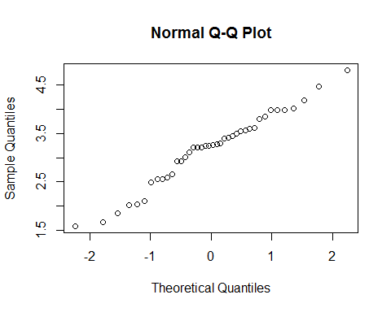

# From QQ Plot, We can say that X is drawn from population close to Normal Distribution.  
  
# b)  
qqnorm(y)

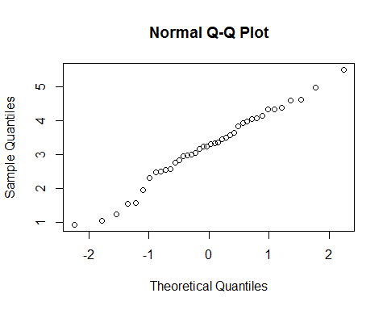

# From QQ Plot, We can say that Y is drawn from population close to Normal Distribution.  
  
# c) Scatter Plot of (x,y)  
binorm.scatter(cbind(x, y))

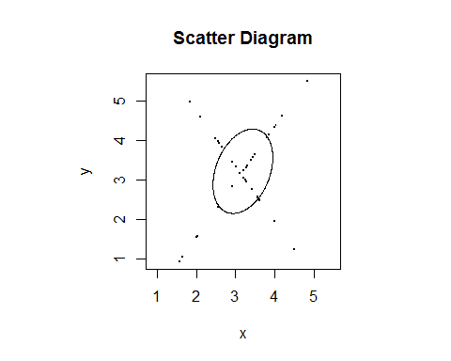

cor(x, y)

## [1] 0.3244167

Since density of data doesn't fit inside ellipse we can say that they are not from bivariate distribution.

# d)

X and Y may be drawn from two different normally distributed population assuming correlation is just by chance.

# Solution 6:-

count<- c(0,1,2,3,4,5,6,7,8,9,10,11,12,13,14)  
freq<- c(57,203,383,525,532,408,273,139,45,27,10,4,0,1,1)  
# a) Average Observed Count   
x_bar=sum(count*freq)/sum(freq)  
x_bar

## [1] 3.871549

# b)   
count1<- c(0,1,2,3,4,5,6,7,8,9)  
freq1<- c(57,203,383,525,532,408,273,139,45,27)  
# Expected Value for 0-9 values  
expected1= dpois(count1,x_bar)*2608  
expected1

## [1] 54.31442 210.28096 407.05653 525.31311 508.44388 393.69308 254.03368  
## [8] 140.50055 67.99435 29.24927

# Expected value for count greater than 10  
expected2=(1-ppois(9,x_bar))*2608  
expected2

## [1] 17.12015

# Combining all the values  
expected=c(expected1,expected2)  
expected

## [1] 54.31442 210.28096 407.05653 525.31311 508.44388 393.69308 254.03368  
## [8] 140.50055 67.99435 29.24927 17.12015

# Observed Values  
observed<- c(57,203,383,525,532,408,273,139,45,27,16)  
# LR chi-squared test  
G2 = 2 * sum(observed * log(observed/expected))  
p=1-pchisq(G2,9)  
# Pearson's chi-squared  
X2 = sum((observed - expected)^2 / expected)  
1 - pchisq(X2, df=9)

## [1] 0.1684555

Unrestricted dimension is 10 where as restricted dimension is 1 hence degree of freedom df=9. If count of alpha particle scintillations follow a Poisson distribution then p= 0.12534 for likelihood ratio test statistics. Hence we cannot dismiss Null Hypothesis that data was drawn from Poisson istribution. Also using Pearson's chisquared test we get larger p value which fails to reject the null hypothesis.